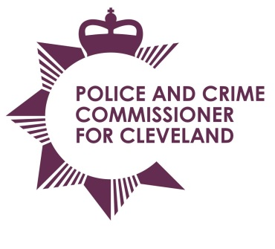
Police & Crime Commissioner for Cleveland
Cleveland Police Headquarters
Ladgate Lane
Middlesbrough
TS8 9EH

Email: pcc@cleveland.pnn.police.uk
Website: http://www.cleveland.pcc.police.uk

Police and Crime Commissioner: Barry Coppinger Tel: 01642 301653
Chief Executive & Monitoring Officer: Simon Dennis BA, Solicitor Tel: 01642 301653
Chief Constable: Iain Spittal Tel: 01642 301217

PCC Scrutiny, Delivery & Performance Meeting

Date: Thursday 28 July 2016
Time: 3pm to 4.30pm
Venue: PCC’s Office, Ladgate Lane

Agenda

 | Apologies For Absence
 | Declaration of conflict of interest/disclosable pecuniary interest
 | Notes of the previous meeting | 
 | Management and Performance Report (eg. TPG/SPG) | 
 | PCC Scrutiny questions | 
Themed Scrutiny - Tackling Reoffending
- LCJB review

 | Forward Plan with Key Events | 
 | Any Other Business
 | Date of next meeting – 2 September 2016 | 

