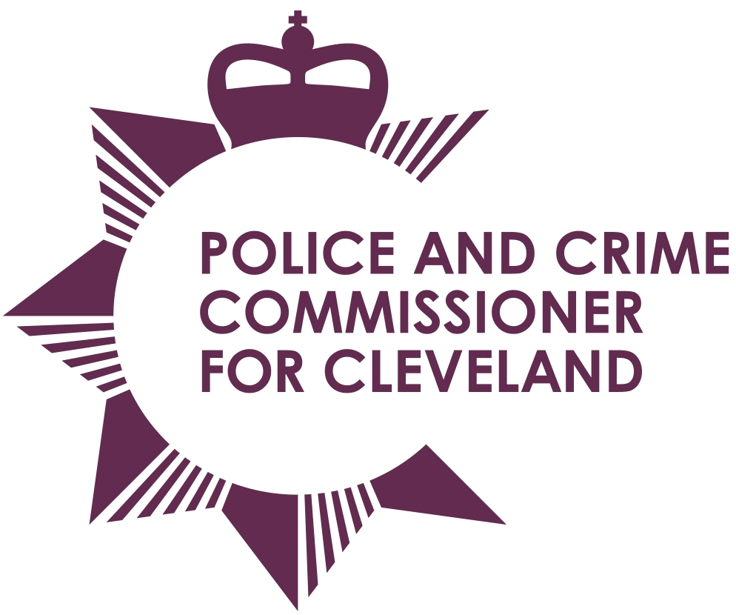
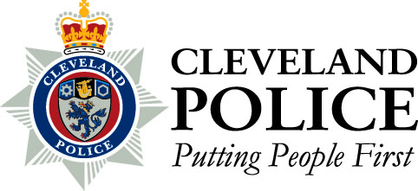

Joint Cleveland Audit Committee

Date: Thursday 21st March 2013
Time: 10.30am – Members to meet at 9.45am
Venue: Executive Conference Room, Police Headquarters, Ladgate Lane

AGENDA

1. | Apologies for absence
2. | Declarations of interests
3. | Minutes of the previous meeting held on 1st February 2013
4. | Civil Claim Statistics – Report of the Chief Constable
5. | Contract Standing Order 9 – Exceptional Situations – Report of the Chief Constable
6. | Annual Governance Statement (Draft) – Report of the Chief Constable
7. | Annual Governance Statement (Draft) – Report of the PCC
8. | Internal Audit Recommendations Implementation Update – Report of the Chief Constable
9. | Progress Report – Report of Internal Audit
10. | Key Financial Controls and Budgetary Control – Visit 2 – Report of Internal Audit
11. | Risk Maturity – Report of Internal Audit
12. | Business / Service Continuity Planning – Report of Internal Audit
13. | Follow Up of Previous Internal Audit Recommendations – Report of Internal Audit
14. | Audit Strategy – Report of the External Audit
15. | Revised Contract Standing Orders – Report of the PCC Chief Finance Officer
16. | To consider passing a resolution pursuant to Section 100A (4) of the Local Government Act 1972, excluding the Press and Public from the meeting under Paragraph 1 of Part 1 of Schedule 12A to the Act
17. | Staffing Update – Report of the Chief Constable

To: The Chair and Members of Joint Cleveland Audit Committee

Mrs Ann O’Hanlon (Chair) Mr Stan Irwin (Vice Chair)
Mr Roman Pronyszyn Mr Gerard Walsh
Mr Aslam Hanif

